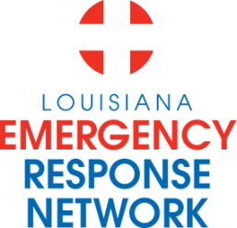

Louisiana Emergency Response Network
Board Meeting
May 16, 2013
2:00pm – 4:00pm
Location: Louisiana Emergency Response Network - Headquarters
14141 Airline Hwy, Suite One, Suite B Baton Rouge, LA 70817

AGENDA
1. Welcome and Introduction of New and Current LERN Board Members
2. Roll Call and Establish a Quorum
3. Approval of Agenda
4. Approval of Minutes of March 21st Board Meeting
5. LERN Business:
- Executive Director Report P. Hargrove
- DHH 5 Year Plan Document
b. Ratification of Commission Members P. Hargrove
c. Communication Center C. Barrett
- discussion related to routing prisoners
- discussion related to routing stroke/STEMI

d. STEMI – Present Protocol: Y. Legendre
- STEMI protocol for patients self-presenting
To STEMI Referral Center

e. STEMI and Stroke White Papers P. Hargrove

f. Senate Bill 198: LERN/BEMS Integration P. Hargrove
g. Budget/Finance P. Sullivan/C. Barr
- Senate Finance Committee/Explanations of
Major reductions/additions

h. LERN Medical Director Report R. Coscia, MD
i. Hartford Paper/Chairman’s Closing Remarks N. McSwain, MD

6. Public Comment
7. Adjournment

BOARD RETREAT DATE – July 19th and 20th, 2013
To be determined

